Q3.Execute the following:

a.Create a concurrent program for the report created in Q2

b.register a concurrent program to a request group

c.submit a Request

d.display the output

**OUTPUT:**

**STEP1:**

**Copying The report to the server path /dbfiles/applcsf/cust/reports/us**

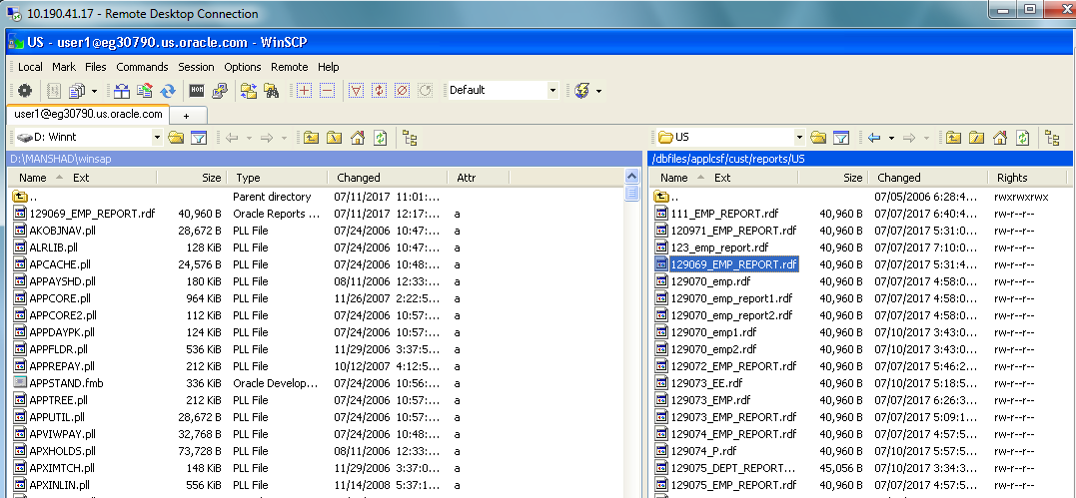

**STEP2:**

**CONNECT TO THE ORACLE SERVER**

**SELECT RESPONSIBILITY : APPLICATION DEVELOPER🡪Profile**

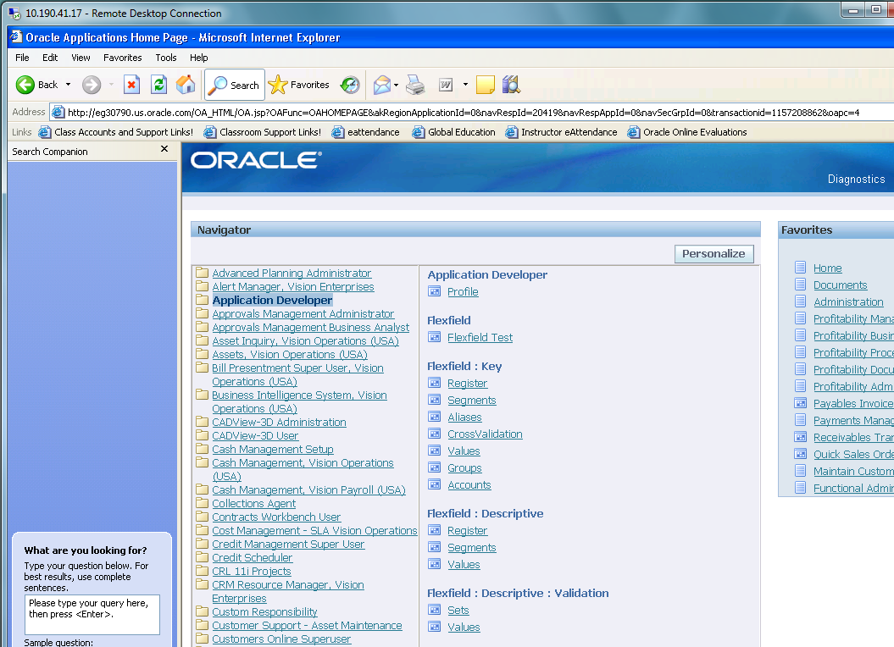

**STEP3:CONCURRENT🡪EXECUTABLES🡪Fill data**

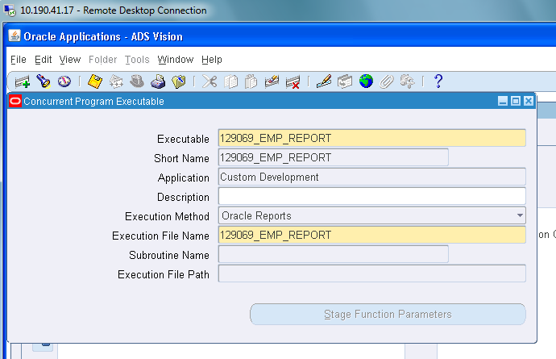

**STEP4:CONCURRENT🡪Programs🡪fill data**

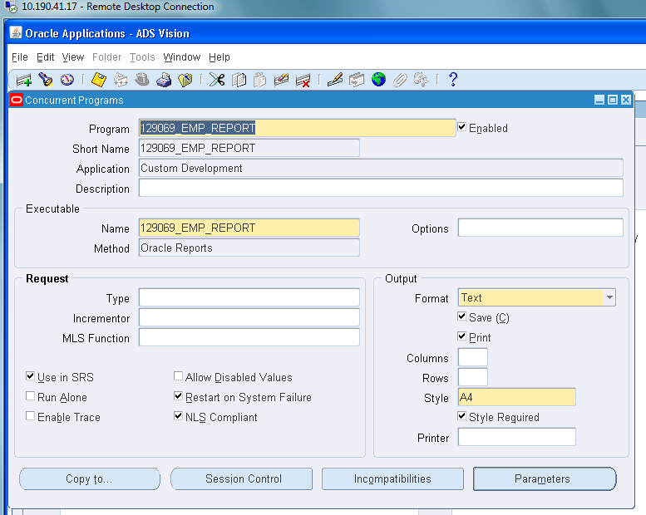

**STEP5:Switch resopnsibilty to System Administrator**

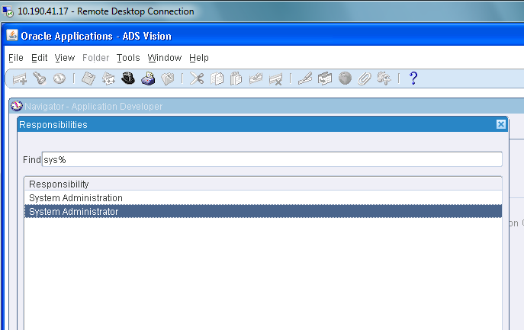

**STEP6:Registering concurrent program to request group**

**SECURITY🡪RESPONSIBILTY🡪REQUEST**

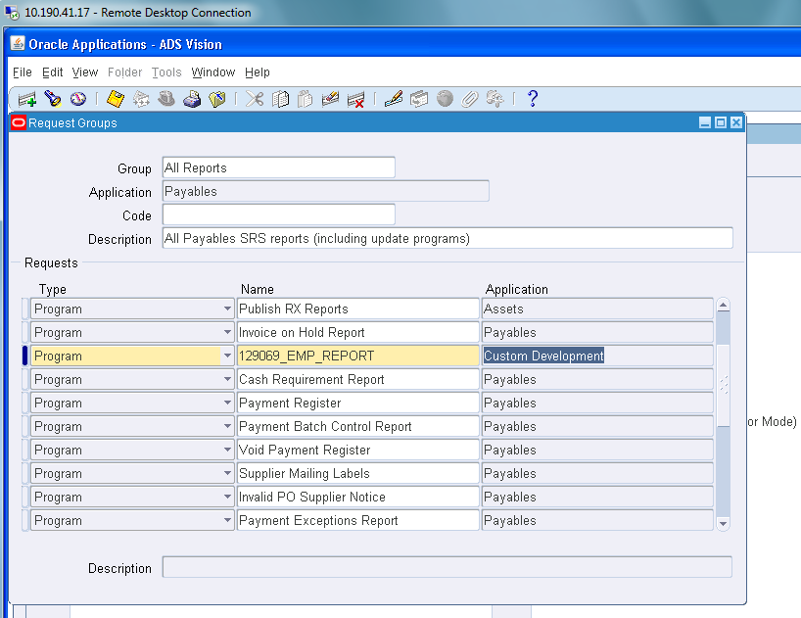

**STEP7:Switch responsibility to Payables vision operation(USA)**

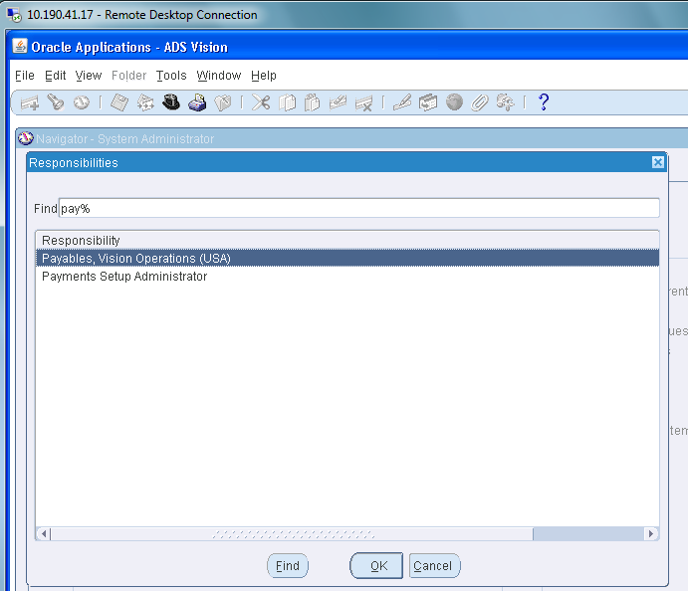

**STEP8:SUBMITTING A REQUEST**

**OTHERS🡪REQUEST🡪RUN**

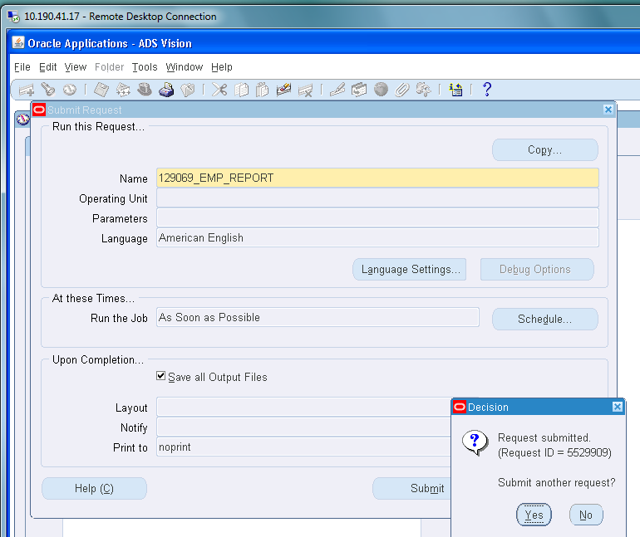

**STEP9: CHECKING STATUS**

**CONCUREENT🡪FIND**

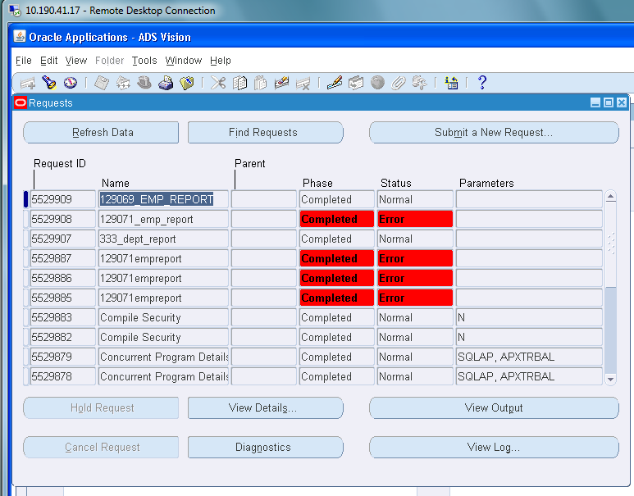

**STEP10: View Output**

